

**Longitudinal/Multilevel Data Analysis -- Spring 2019**

**May 7th, 2019**

**Kimmi-Yiziying Chen**

**Longitudinal Study of Mixed and Random Effects for Suicide Rates and**

**Predictions by Associated Global Covariates**

**"Stayin' Alive, Stayin' Alive" - The Office**



**ABSTRACT**

**Background:** ​The Suicide Rates Overview 1985 to 20161​ ​ dataset was compiled in 2018 from data collected by the World Bank2​ ​, the United Nations Development Program3​ ​, the Suicide in the Twenty-First Century4​ ​ dataset, and the World Health Organization5​ ​ over the span of three decades. The purpose in combining this information linked by date and location is to track global progress and trends in suicide to aid prevention and awareness programs, which are currently in place in 60 countries, according to the World Health Organization. The purpose of this study is to analyze geographical and socio-economic trends in suicide between age groups and generations in 101 countries. Note, for the purposes of brevity, six countries are focused on in greater detail for the bulk of the analysis.

**Methods:** ​The main variables of interest for the study are number of suicides, suicide rate per 100k, year, country, sex, age, GDP (gross domestic product) per capita, population, and generation. Descriptive statistics and various tests, such as Chi-squared, likelihood-ratio and Mantel-Haenszel Chi squared tests were performed to identify significance between categorical variables. Then, after paring down a full regression model to an ANOVA model based on stepwise-selected values, contrast tests were conducted, and linear mixed effect models were built, as well, utilizing five different correlation working structures. Further tests and models were constructed, as outlined in the study.

**Results:** ​From the various analyses, the data shows interesting insight between suicide rates of

countries and age groups, more specifically, generations. Among the six countries analyzed in

the model, Japan has the highest log odds of suicide, whose odds ratio compared to the country

with the lowest log odds, Mauritius, is 12.2215. To compare suicide rates of generations, the contrast testing gave significant differences between 1st and 2nd, 2nd and 3rd, 2nd and 4th, 2nd and 5th, 4th and 5th. However, the rates do not uniformly increase or decrease from generation to generation. All generations showed significant differences when compared to the 6th generation, but this could be due to data limitations and the relative youth of this age group currently. The fixed age effect shows that a one-year increase in age, regardless of generation or country, shows an approximately 4.93% decrease in chance of suicide.

**Conclusion:** Suicide differs from country to country and by gender and generations of individuals that go through positive and negative experiences throughout life. The stratified representation of genders over time shows that age grouping plays a significant role in suicide rates over time, rather than the simple rate of suicide of the entire country. It is shown that men are more at risk of committing suicide than women, and that overall rates are potentially decreasing over time. These pieces of information can inform the way organizations prepare suicide prevention materials

**INTRODUCTION**

Suicide is defined as the act of ending one's life, of which the behaviors include any thoughts or tendencies that put a person at risk6​ ​. From other public health coursework, it is known that suicide is a global crisis, and claims approximately 800,000 lives per year from 60 countries that report statistics on this topic7​ ​.

In 2017, suicide was the 10th leading cause of death overall in the United States (CDC)8​ ​. It's been studied that the total number of attempted suicide and thoughts of committing suicide are growing after year 2000, especially among young people. Suicide study has becoming a big topic in today's world and relevant statistical studies are to be carried out for better evaluating repeated measures of predictive factors' association with annual suicide rate.

Because of this, suicide was chosen as the topic of the study. Of the 27,820 available observations from 12 variables, 2,230 observations were used in this study for model building purposes. The interest of this study is annual suicide rate repeatedly measured among different countries. Generation, age group, country of residence, and GDP of the country one lives in all impact the odds of an individual committing suicide, and the overall population suicide rates. The purpose of investigating these various categories of data is to specify the exact impacts of these different stratifications, in order to have a better understanding of how to strategize possible prevention techniques. For example, if generation plays the most significant role in determining odds of suicide, then further research can be done as to what a particular generation has experienced to lead to this particular effect.

**METHODS**

The dataset structure was assessed and subsetted to include six countries' yearly suicide data information. Statistical features, including mean, min and max values were obtained for each numeric variable. Frequency tables were created and Chi-squared, likelihood-ratio and Mantel-Haenszel Chi squared test were performed for testing significant associations between categorical variables (whether OR = 1). Average patterns of suicide trends were plotted by year and age over country, gender, generation groups to get a sense of the range of variability of the data, and to see if there were sex*year, sex*age, generation*year, generation*age, country*age or country*year effects.

A full regression model was built using all attributes. An ANOVA model was built using the predictors picked from stepwise selection upon the full regression model with year-specific intercept as random effects. Contrast tests were conducted to catch any significant difference in suicide rates between different generations.



Dummy variables were created for six countries. Linear mixed-effect models were built upon using five different correlation working structures (simple, exponential, Compound symmetry-CS, AR(1), and Toeplitz) with repeated measure and intercept as random effect. The hypothesis test was performed by comparing model AIC scores to find the correlation working structure that fits the data best. Additional diagnostics were performed upon the final linear

mixed-effect model:

1. Normality check of the random effects using histogram

2. Check any systematic departures with raw residual plots on subject level and population

level - two types of plots were drawn, residuals against the predicted mean and residuals

against covariates

3. Check any systematic departures with scaled residual plots

4. Normality check of transformed residuals using QQ plot

Population average residuals and subject specific residuals were used to plot two semivariograms. Contrast tests were performed for testing the significant differences in suicide rate trajectories between countries.

Suicide rate was further categorized into four levels, using the four quartiles of the numeric suicide rate values as cutoff lines. A multinomial logistic model was fitted on the full model using selected correlation working structure AR(1) and random intercept. The tests of fixed effects showed us significant covariates for predicting ordinal suicide rate response.

Some limitations were met during the analysis. When building a binary probit logistic regression model, the numeric outcome, suicide rate, was categorized into two levels with 0 for no suicide and 1 for any suicide. The characterization approach itself was not supported by any standard protocol and could result in loss of prediction power. Upon probit model fitting, the correlation matrix for R didn't converge for the chosen working structure, AR(1). Therefore, no prediction of log odds results can be assessed from the binary logistic mixed-effect model. Besides, the characterization approach used for creating ordinal suicide rate outcome was not profound enough and may be used on a different dataset for statistical analysis. When fitting a generalized estimating equation (GEE) model using binary suicide response with country as within-subject effect, there were not as many levels of the country effect as there were measurements for each subject. Thus, we failed to process GEE analysis on our dataset. Potential suggested future improvements could be altering data collection protocols in order to enable more extensive longitudinal/multilevel data analysis.

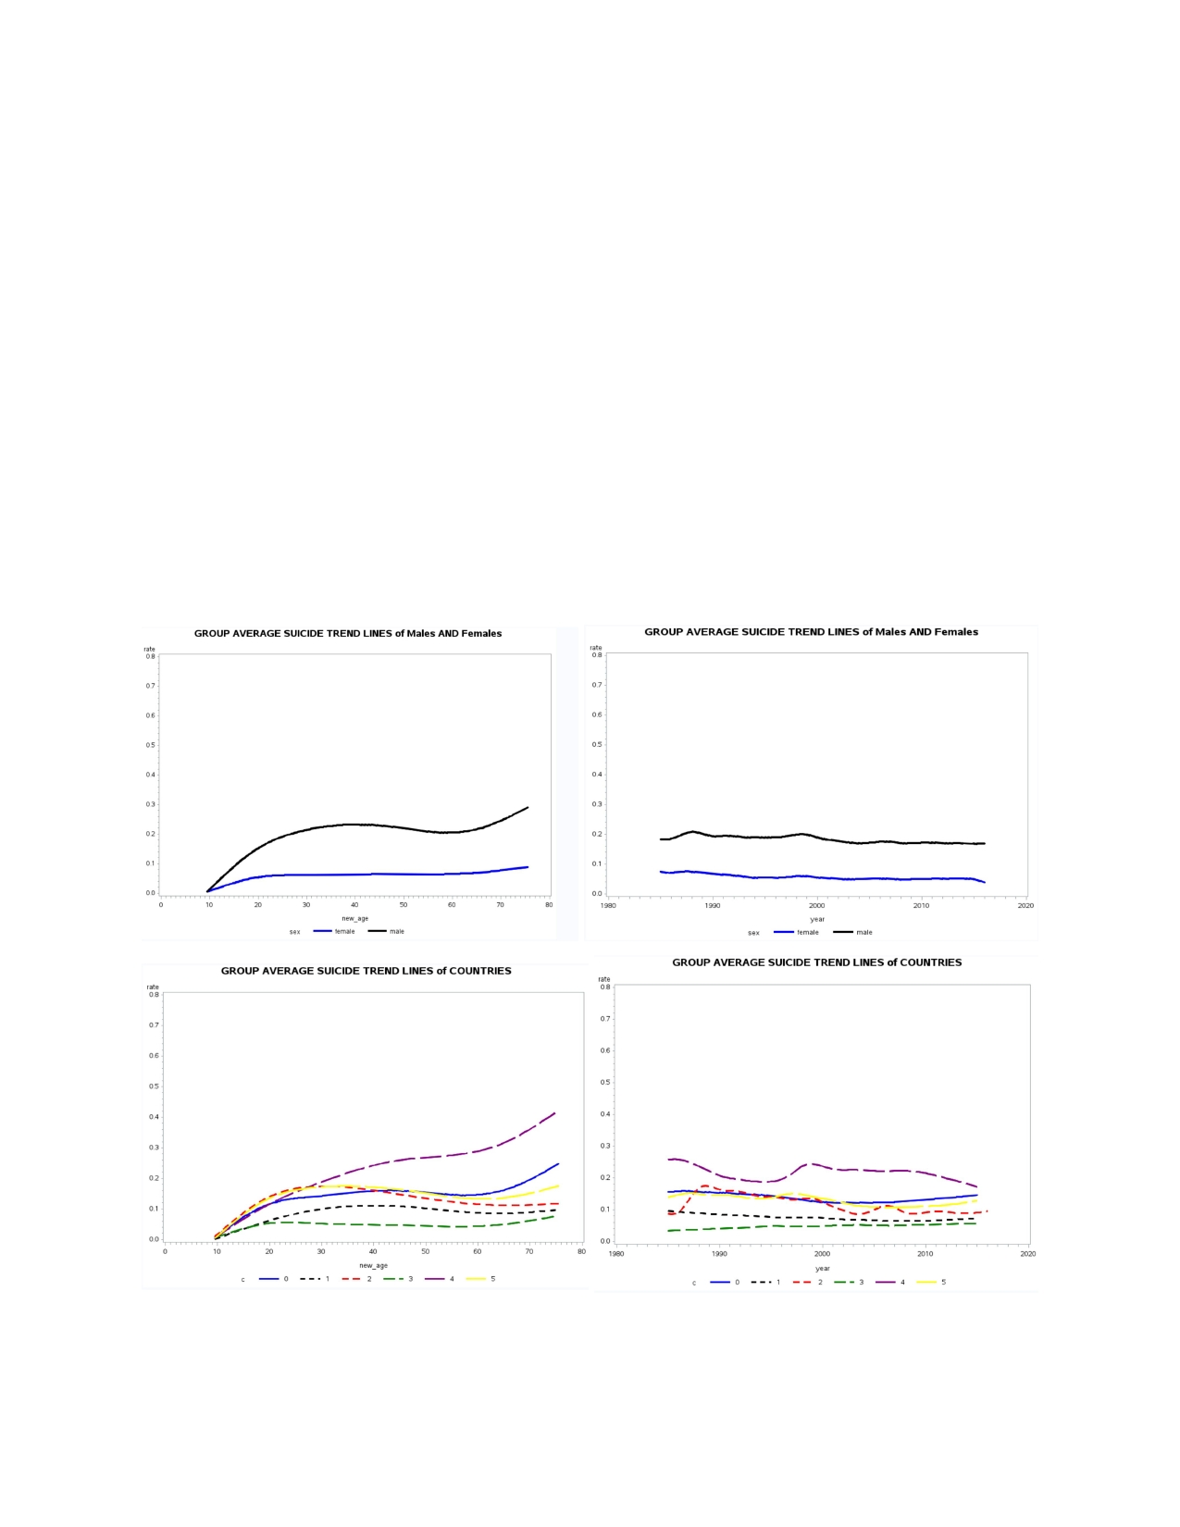

**RESULTS**

The original dataset contained 101 countries' yearly suicide rate together with GDP, gender, generation and age groups' information from years 1985 to 2016. The dataset was subsetted using the suicide information of six countries: United States, United Kingdom, Mauritius, Mexico, Japan and Australia, each from six continents, for conducting statistical analysis. Categorical variables age group range were transformed into continuous age variables using the midpoint age value (use age = 75.5 for 75+ age group). Categorical variable generation was relabeled as follows: G.I. Generation = 0, Silent = 1, Boomers = 2, Generation X = 3, Millenials = 4, and Generation Z =5. Averaged annual suicide rate trend lines were plotted over year and age between genders, countries and generations. Plots giving clear differences of annual suicide trend among groups were presented in Panel 1.

Panel 1. Averaged Suicide Trend Lines over Year and Age between Gender (upper 2 plots) and

Country (lower 2 plots) Categories

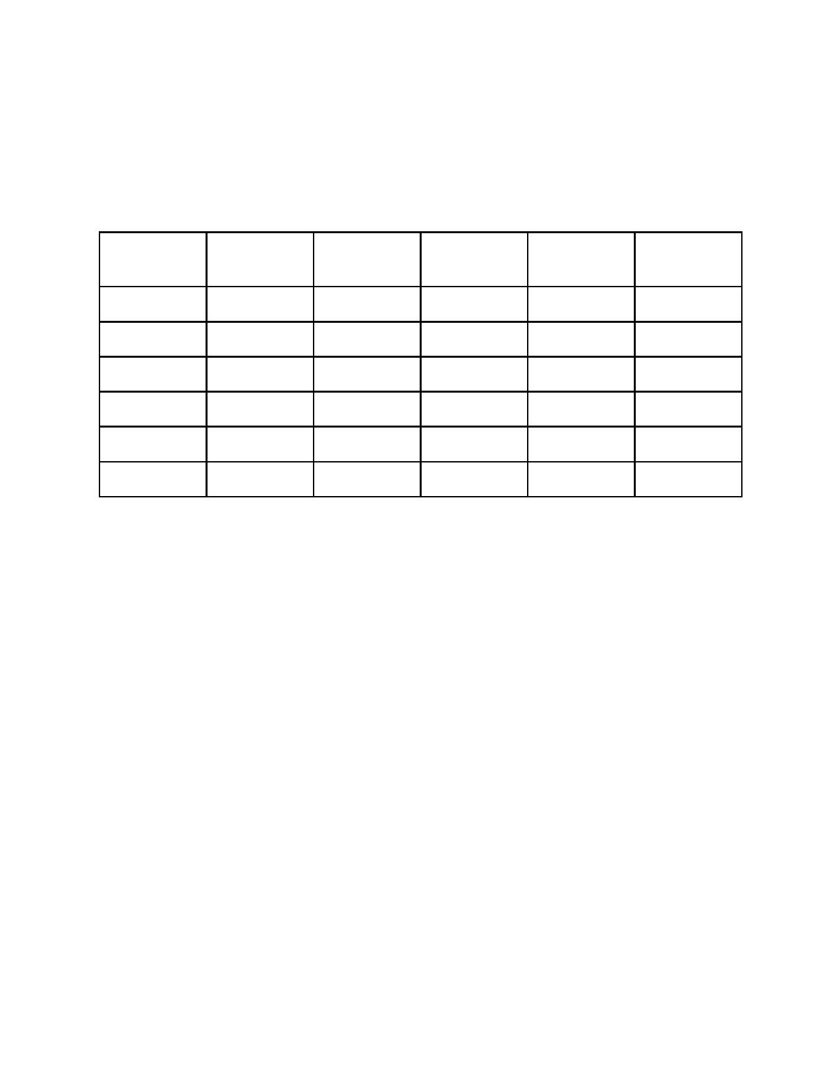

Stepwise selection of the full regression model (a) was performed at 0.15 significance level and the summary of the final model is given in Table 1. Predictors remained in the model were sex_cat, new_age, gdp_capita, year and generation. Detailed fitting diagnostics for the final regression model (model a) using picked predictors were included in Appendix Panel 1.

Table 1. Summary of Stepwise Section from the Full Regression Model (a)

Variable Parameter Standard Type II SS F value Pr>F

Estimate Error

Intercept 3.80984 0.89581 0.15946 18.09 <0.0001

sex_cat -0.12675 0.0098 8.95594 1015.86 <0.0001

generation -0.01222 0.00658 0.03037 3.45 0.0635

Numeric age 0.00138 0.00037106 0.12121 13.75 0.0002

year -0.00185 0.00046073 0.14179 16.08 <0.0001

GDP capita 0.00000165 1.278155e-7 1.47288 167.07 <0.0001

The summary of the repeated-measures ANOVA model (b) gives F test results (F = 17.96, df = 192, p < 0.0001) for the fitting of the model using independent variables listed in Appendix Table 1. See Appendix Table 1 for detailed Type III analysis summary of model (b). Multiple contrast tests were performed for detecting significant difference in suicide rate between generation groups. At 0.05 significance level, pairwise contrast, 1 vs. 2 (p < 0.0001), 2 vs. 3 (p < 0.0001), 2 vs. 4 (p < 0.0001), 2 vs. 5 (p = 0.0432), 3 vs. 6 (p = 0.0131), 4 vs. 5(0.0029), 4 vs. 6 (p < 0.0001), 5 vs. 6 (p = 0.0003) appear to be significant (see Appendix Table 2 for complete contrast tests summary).

Several linear mixed-effect models were built for tracing the between-subject and within-subject sources of variation in the suicide rate, using simple [model c], exponential, Compound Symmetry (CS) [model d], AR(1) [model e], and Toeplitz correlation working structures, respectively. The best working structure, AR(1), was chosen as it minimized AIC value (model c: AIC = 14658.0, model d: AIC = 14654.8, model e: AIC = 14265.3). Using AR(1), correlation parameter estimates given by model (d) (LR test, Chi-Square = 233.99, df = 2, p < 0.001) was summarized in Appendix Table 3 (see Appendix Table 4 for solutions of fixed effects). To check the fitting of model (d), a normality check of the random effect was evaluated using the histogram (see Figure 1) together with Goodness-of-fit test (Table 2). The test results were significant at 0.05 significance level.

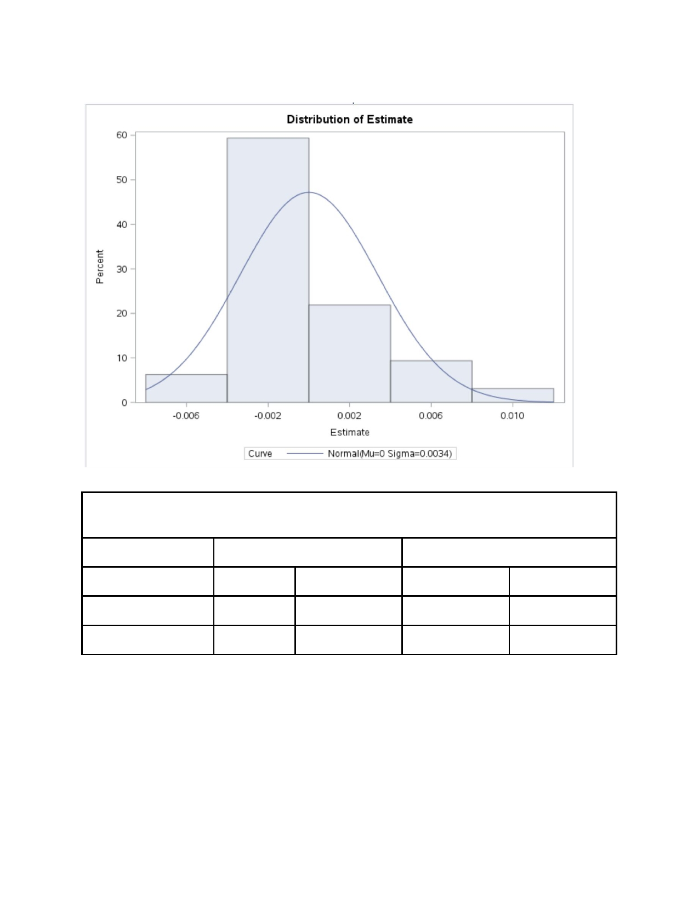

Figure 1. Histogram for Distribution of Random Effects from Model (d)

Table 2. Goodness-of-fit Tests Results for Normal Distribution of Random Effects from Model

(d)

Test Statistics P value

Komogorov-Smirnov D 0.2011 Pr>D <0.01

Cramer-von Mises W-Sq 0.1981 Pr>W-Sq <0.005

Anderson-Darling A-Sq 1.0271 Pr>A-Sq 0.009

Population-averaged raw residuals and subject-specific raw residuals were plotted against the predicted mean in Panel 2 for checking any obvious pattern and constant residual variation. Plots of raw residuals against each covariate can be found in Appendix Panel 3 (population averaged) and Panel 4 (subject-specific).

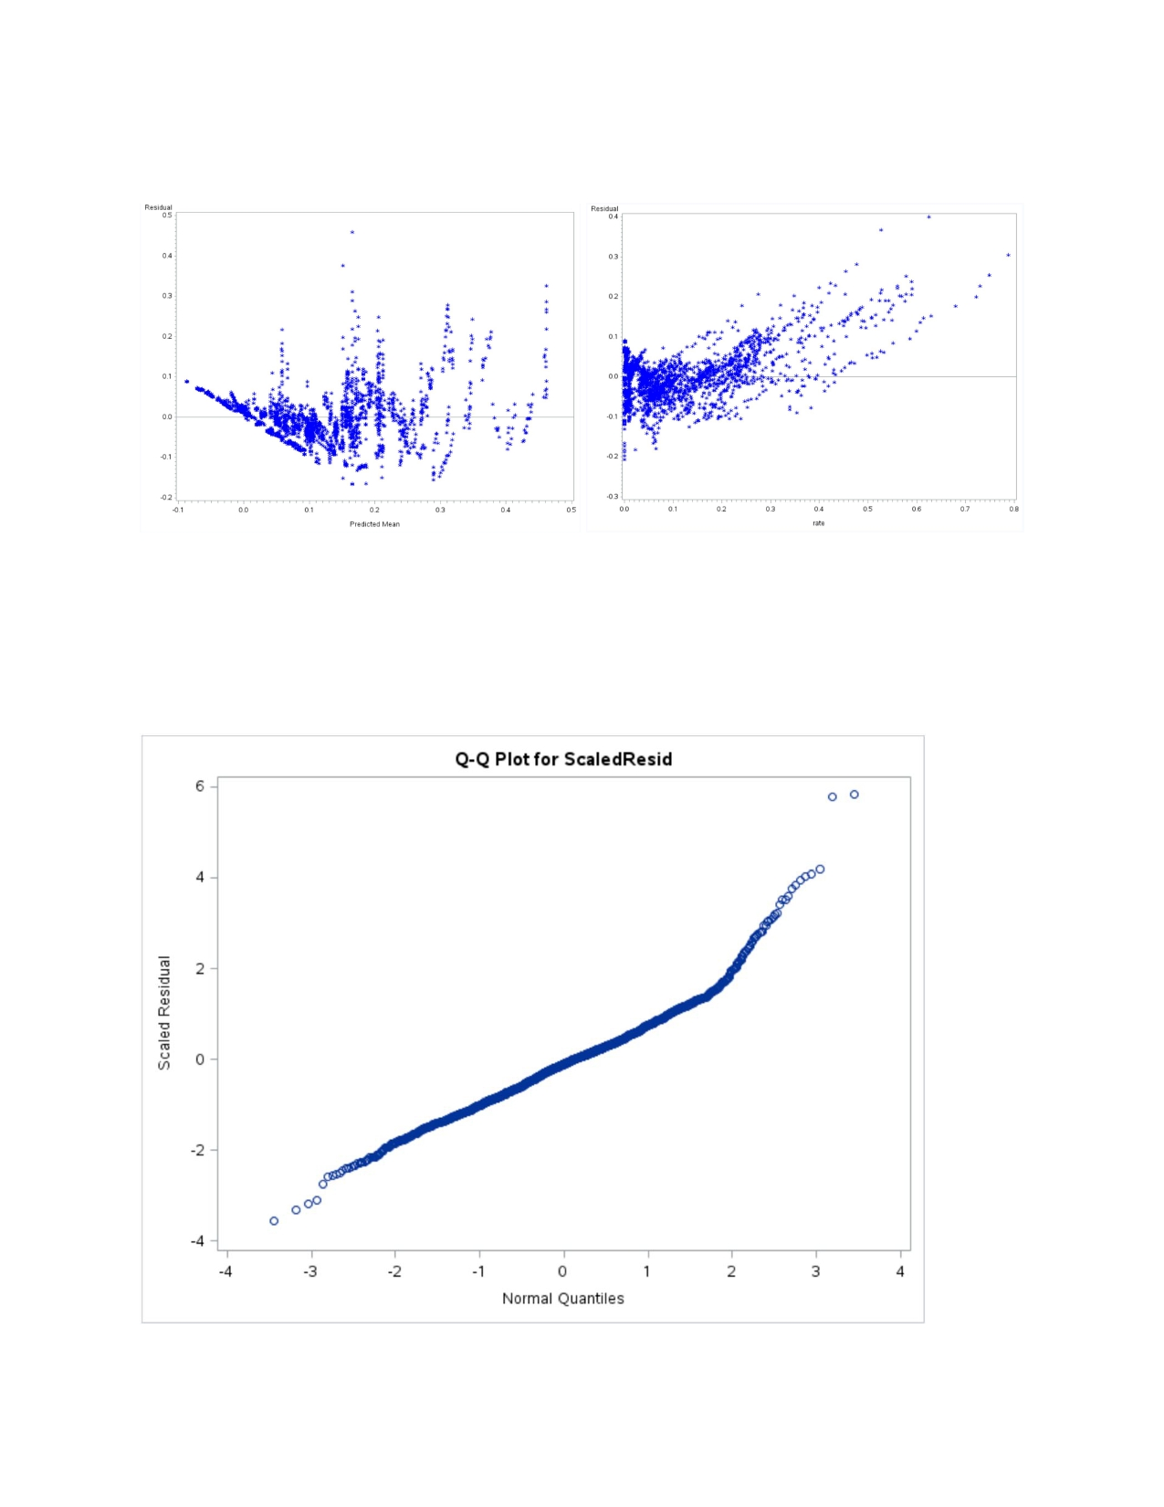

Panel 2. Population-averaged (left) and Subject-Specific (right) Raw Residuals against Predicted

Suicide Rate Mean from Model (d)

Scaled residual QQ plot (Figure 2) was generated to check the linearity trend to further examine

the fitting of model (d) on the data. Difference of residuals between two time points was assessed using semi-variogram at population-averaged level and subject-specific level (Panel 3).

Figure 2. QQ Plot for Scaled Residuals from Model (d)

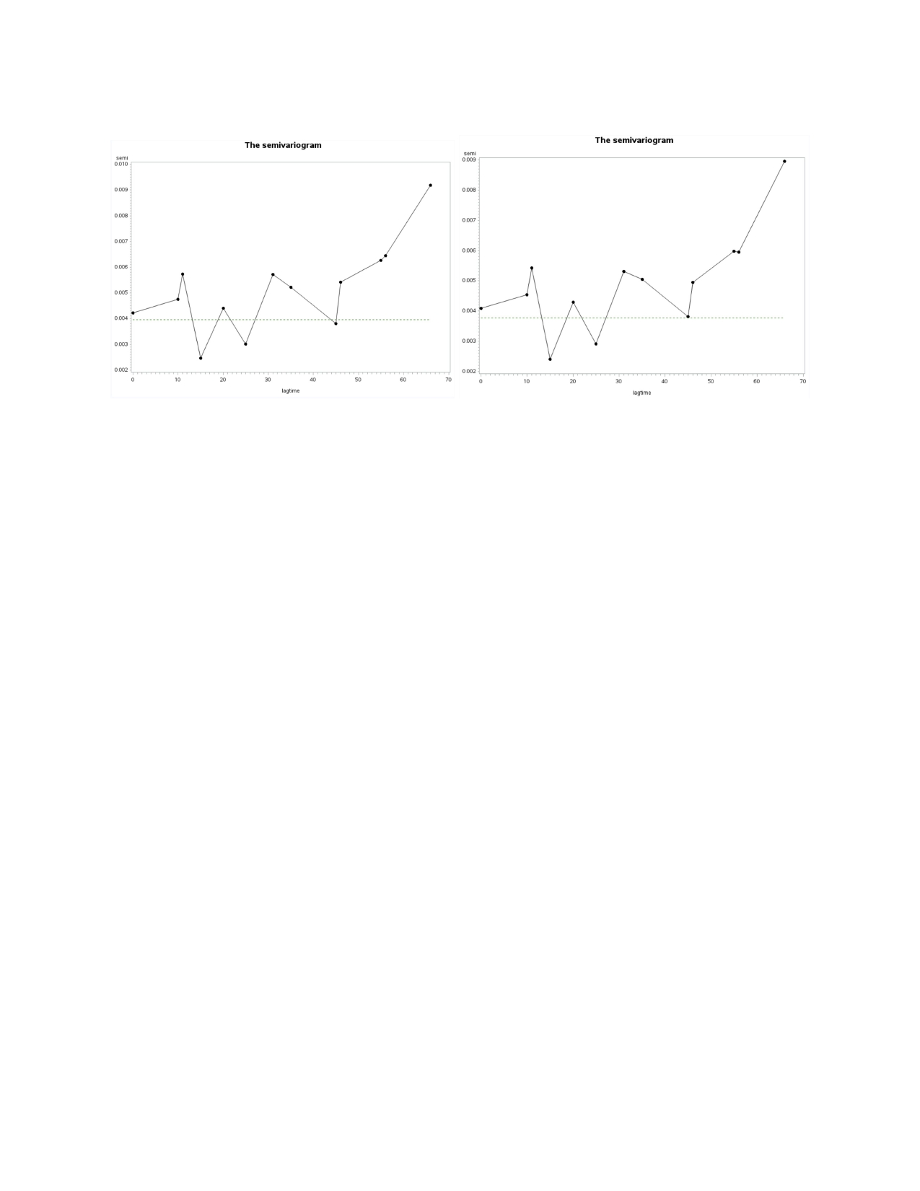

Panel 3. Population-averaged (left) and Subject-Specific (right) semi-variograms

The next topic of study was difference in yearly suicide rate trajectories between repeated measures of six countries. Contrast tests were performed upon repeated measure mixed-effect model (e), and test results were summarized in Appendix Table 5. Test results (p < 0.0001) indicated repeated measure of annual suicide rates between any pairwise countries were significantly different from each other. Model (e) residual assumptions were assessed by graphic results (retrieved from Appendix Panel 5).

Another topic of interest was in determining how the ordinal suicide rate response variable was affected by country, generation, GDP capita, numeric age and population considering random intercept in the model. A multinomial logistic random-intercept model for ordinal response (model f) was fitted using cumlogit link. The summary of solutions for fixed effects were included in Appendix Table 6. At 0.05 significance level, significant fixed effects were country (p < 0.0001), generation (p < 0.0001), numeric age (p < 0.0001) and population (p = 0.0433).

**DISCUSSION**

Given the averaged suicide cohort trend over numeric ages and years (Panel 1), males seem to have higher suicide rates than females and the overall suicide rates do not shift a high amount for both genders over the years. Both males and females have increased average suicide rate among older individuals (aged >60). Some possible explanations towards higher suicide rates among elders could be becoming a widow/widower or having mental and physical illnesses9​ ​. Within the range of this study, Japan appears to have much higher overall suicide rate compared to the other five countries.



In studying the annual suicide rate with repeated measures, the ANOVA model supports significant pairwise suicide rate differences between the Silent generation (1925-1945) and the rest of the generations. Children from this group were plagued with war and economic instability10​. These social conditions could be major factors having long term impacts on the overall suicide rate of the silent generation.

In order to study the between-subject and within-subject variations in suicide rate, AR(1) is chosen to act as the best correlation working structure. The individual subject of the study is annual suicide rate fixed effects of country, population, gender, GDP per capita, the interaction between country and numeric age, and the interaction between country and numeric age squared values. Country, GDP per capita, and gender have a significant association with suicide rate. Random effects, intercept, is normally distributed, and scaled residuals follow a linear trend, both of which indicate a good fit of the linear mixed-effect model onto the dataset. A clear increasing trend of variation among subject-specific raw residuals over suicide rates (Panel 2) indicates difficulties are met in predicting high (greater than 25%) averaged suicide rates. Similarities in the 2 sevimariograms (Panel 3) suggest a good representation of subject-level mix effects on to the compiled population-averaged level. Higher variances exist within predicting suicide rate among males, people with high age, early generations and country with low GDP capita and low population at both population and subject level.

When analyzing the repeated measures of annual suicide rates among six countries, suicide rates are found to be different among the repeated measures of the same year. Japan has the highest overall odds of suicide and Mexico has the lowest odds of suicide. Controlling country, generation and gender effects, younger people tend to have higher chance of committing suicide. A 1 million increase in population will result in 2 percent decrease chance in suicide adjusting for country, age and gender effects.

**CONCLUSION**

To conclude, it was discovered that generation, gender, and country play significantly into the outcome of an annual suicide committing rate, and GDP and other variables can account for variation in suicide rates between countries. As shown in Panel 3 of the Results section, the population vs. the subject specific trends of the semivariogram are quite similar but still differing slightly, meaning the underlying data supports the high-level trends that are being analyzed. Population level suicide rates were more successfully predicted in the models than subject level suicide rates, though both analyses were able to be performed at a significant level.



This study did dive into extensive population demographic analysis into areas such as religious stigma around suicide, that could perhaps better explain, along with relative wealth of a country, why suicide rates are comparatively higher or lower. For example, it could be postulated that Mexico has a lower suicide rate than the United States because of the combined influence of a lower GDP per capita and a dominant influence of Catholicism in the population, which highlights the importance of an afterlife, the outcome of which is affected by suicide.



**ENDNOTE CITATIONS**

1. Rusty. "Suicide Rates Overview 1985 to 2016." Kaggle. 01 Dec. 2018. 15 Apr. 2019 <https://www.kaggle.com/russellyates88/suicide-rates-overview-1985-to-2016>.

2. "World Development Indicators." ​*DataBank*​,

databank.worldbank.org/data/source/world-development-indicators#.

3. "Human Development Reports." ​*Human Development Reports*​,

hdr.undp.org/en/indicators/137506.

4. "Suicide in the Twenty-First Century." ​*Kaggle*​,

www.kaggle.com/szamil/suicide-in-the-twenty-first-century/notebook.

5. "Suicide Prevention." ​*World Health Organization*​, World Health Organization, 29 Jan. 2019,

www.who.int/mental_health/suicide-prevention/en/.

6. "Suicide and Suicidal Behavior." ​*Encyclopedia of Children's Health*​,

www.healthofchildren.com/S/Suicide-and-Suicidal-Behavior.html.

7. WHO op. Cit.

8. "Suicide." ​*National Institute of Mental Health*​, U.S. Department of Health and Human

Services, www.nimh.nih.gov/health/statistics/suicide.shtml.

9. Conejero, Ismael, et al. "Suicide in Older Adults: Current Perspectives." ​*Clinical Interventions*

*in Aging*​, Dove Medical Press, 20 Apr. 2018,

www.ncbi.nlm.nih.gov/pmc/articles/PMC5916258/.

10. "The Silent Generation." ​*Study.com*​, Study.com, 14 Feb. 2018,

study.com/academy/lesson/the-silent-generation-definition-characteristics-facts.html

**APPENDIX**

Script 1: SAS code used to perform data analysis and model building.

/*import ​data​*/

%let path = /home/Longitudinal/;

proc import datafile=​"&path.master.csv"​ dbms=csv out=suicide replace;

informat HDI ​6​.;

run;

data​ all_suicide;

infile ​"&path.master.csv"

delimiter=​','​ missover

firstobs=​2​ DSD lrecl = ​32767​;

informat country ​$20​.;

informat year best12.;

informat sex ​$6​.;

informat age ​$11​. ;

informat suicide_no best12. ;

informat population best12.;

informat suicide_rate best12.;

informat contry_year ​$7​.;

informat HDI best12.;

informat gdp ​$15​.;

informat gdp_capita best12.;

informat generation ​$15​.;

format country ​$20​.;

format year best32.;

format sex ​$6​.;

format age ​$11​. ;

format suicide_no best32. ;

format population best32.;

format suicide_rate best32.;

format contry_year ​$7​.;

format HDI best32.;

format gdp ​$15​.;

format gdp_capita best32.;



format generation ​$15​.;

input country $

year

sex $ age $

suicide_no population

suicide_rate

contry_year $

HDI gdp

gdp_capita

generation $

;

run;

/*male = ​0​, female =​1​*/

data​ suicide;

set all_suicide;

if​ generation = ​'G.I. Generation'​ then gen = ​0​;

else​ ​if​ generation = ​'Silent'​ then gen = ​1​;

else​ ​if​ generation = ​'Boomers'​ then gen = ​2​;

else​ ​if​ generation = ​'Generation X'​ then gen = ​3​;

else​ ​if​ generation = ​'Millenials'​ then gen = ​4​;

else​ ​if​ generation = ​'Generation Z'​ then gen = ​5​;

if​ sex = ​'male'​ then sex_cat = ​0​;

else​ sex_cat = ​1​;

if​ age = ​'5-14 years'​ then ​do​ age_cat = ​0​; new_age = ​9.5​; ​end​;

if​ age = ​'15-24 years'​ then ​do​ age_cat = ​1​; new_age = ​19.5​; ​end​; if​ age = ​'25-34 years'​ then ​do​ age_cat = ​2​; new_age = ​29.5​; ​end​; if​ age = ​'35-54 years'​ then ​do​ age_cat = ​3​; new_age = ​44.5​; ​end​; if​ age = ​'55-74 years'​ then ​do​ age_cat = ​4​; new_age = ​64.5​; ​end​;

if​ age = ​'75+ years'​ then ​do​ age_cat = ​5​; new_age = ​75.5​; ​end​;

ID = _n_;

age2 = new_age*new_age;

pop2 = population*population;

rate = suicide_rate/​100​;

if​ rate >​0​ then rate_cat = ​1​; ​else​ rate_cat = ​0​;



if​ country ​in​ (​'United Kingdom'​,​'United States'​, ​'Mauritius'​,

'Mexico'​, ​'Japan'​, ​'Australia'​) then output;

run;

Libname out ​'/home/Longitudinal/'​;

data​ out.suicide_data;

Set suicide;

Run;

*check US suicide ​data​ structure;

proc univariate ​data​ = suicide; RUN; proc contents ​data​=all_suicide; run;

proc contents ​data​=suicide; run;

proc means ​data​ = suicide; var rate; run;

proc contents ​data​=country_count;run;

/******************************************************

************EXPLORATORY ANALYSIS;

******************************************************/

title ​"exploring data features"​;

/*DESCRIPTIVE STATISTICS: FREQUENCY TABLES*/

proc freq ​data​=all_suicide;

tables country /out=country_count nofreq;

run;

proc sort ​data​=country_count;

by descending count ; quit;

run;

proc print ​data​ = country_count;

run;

proc freq ​data​=suicide;

tables rate/out=rate_range;

run;

proc freq ​data​=suicide;

tables sex*year/norow nopercent CHISQ;



tables tables tables tables

run;

generation*year/norow nopercent CHISQ;

age*year/norow nopercent CHISQ;

age*sex/norow nopercent CHISQ;

age*generation/norow nopercent CHISQ;

*average trend plot;

**(​1​)AGE to suicide rate by sex;

goptions reset=all;

proc gplot ​data​=suicide;

plot rate*new_age = SEX;

symbol V=NONE I=SM50S COLOR=BLUE WIDTH=​3​;

SYMBOL2 V=NONE I=SM50S COLOR=BLACK WIDTH=​3​;

TITLE ​'GROUP AVERAGE SUICIDE TREND LINES of Males AND Females'​; RUN;

QUIT;

**(​2​)YEAR to suicide rate by SEX;

proc gplot ​data​=suicide;

plot rate*YEAR = SEX;

symbol V=NONE I=SM50S COLOR=BLUE WIDTH=​3​;

SYMBOL2 V=NONE I=SM50S COLOR=BLACK WIDTH=​3​;

TITLE ​'GROUP AVERAGE SUICIDE TREND LINES of Males AND Females'​; RUN;

QUIT;

**(​3​)AGE to suicide rate by GENERATION;

proc gplot ​data​=suicide;

plot rate*new_age = GEN;

symbol V=NONE I=SM50S COLOR=BLUE WIDTH=​2​ line=​1​;

SYMBOL2 V=NONE I=SM50S COLOR=BLACK WIDTH=​2​ line=​2​;

SYMBOL3 V=NONE I=SM50S COLOR=RED WIDTH=​2​ line=​3​;

SYMBOL4 V=NONE I=SM50S COLOR=GREEN WIDTH=​2​ line=​4​;

SYMBOL5 V=NONE I=SM50S COLOR=PURPLE WIDTH=​2​ line=​5​; SYMBOL6 V=NONE I=SM50S COLOR=YELLOW WIDTH=​2​ line=​6​;

TITLE ​'GROUP AVERAGE SUICIDE TREND LINES of GENERATIONS'​; RUN; QUIT;

**(​4​)YEAR to suicide rate by GENERATION;

proc gplot ​data​=suicide;

plot rate*YEAR = GEN;



symbol V=NONE I=SM50S COLOR=BLUE WIDTH=​2​ line=​1​;

SYMBOL2 V=NONE I=SM50S COLOR=BLACK WIDTH=​2​ line=​2​;

SYMBOL3 V=NONE I=SM50S COLOR=RED WIDTH=​2​ line=​3​;

SYMBOL4 V=NONE I=SM50S COLOR=GREEN WIDTH=​2​ line=​4​;

SYMBOL5 V=NONE I=SM50S COLOR=PURPLE WIDTH=​2​ line=​5​; SYMBOL6 V=NONE I=SM50S COLOR=YELLOW WIDTH=​2​ line=​6​;

TITLE ​'GROUP AVERAGE SUICIDE TREND LINES of GENERATION'​; RUN; QUIT;

**(​5​)YEAR to suicide rate by Country;

proc gplot ​data​=suicide;

plot rate*YEAR = C;

symbol V=NONE I=SM50S COLOR=BLUE WIDTH=​2​ line=​1​;

SYMBOL2 V=NONE I=SM50S COLOR=BLACK WIDTH=​2​ line=​2​;

SYMBOL3 V=NONE I=SM50S COLOR=RED WIDTH=​2​ line=​3​;

SYMBOL4 V=NONE I=SM50S COLOR=GREEN WIDTH=​2​ line=​4​;

SYMBOL5 V=NONE I=SM50S COLOR=PURPLE WIDTH=​2​ line=​5​; SYMBOL6 V=NONE I=SM50S COLOR=YELLOW WIDTH=​2​ line=​6​;

TITLE ​'GROUP AVERAGE SUICIDE TREND LINES of COUNTRIES'​; RUN; QUIT;

**(​6​)AGE to suicide rate by GENERATION;

proc gplot ​data​=suicide;

plot rate*NEW_AGE = C;

symbol V=NONE I=SM50S COLOR=BLUE WIDTH=​2​ line=​1​;

SYMBOL2 V=NONE I=SM50S COLOR=BLACK WIDTH=​2​ line=​2​;

SYMBOL3 V=NONE I=SM50S COLOR=RED WIDTH=​2​ line=​3​;

SYMBOL4 V=NONE I=SM50S COLOR=GREEN WIDTH=​2​ line=​4​;

SYMBOL5 V=NONE I=SM50S COLOR=PURPLE WIDTH=​2​ line=​5​; SYMBOL6 V=NONE I=SM50S COLOR=YELLOW WIDTH=​2​ line=​6​;

TITLE ​'GROUP AVERAGE SUICIDE TREND LINES of COUNTRIES'​; RUN; QUIT;

/******************************************************

************REPEATED MEASURE;

******************************************************/

*CONTRASTS;

proc reg ​data​=suicide;

model rate = sex_cat gen population new_age year gdp_capita/

selection=stepwise;

run;



proc glm ​data​=suicide;

class sex gen year c;

model rate = c sex gen new_age year(c) gdp_capita/solution;

random year(c);

contrast ​'Linear Trend contrast'​ GEN -​5​ -​3​ -​1​ ​1​ ​3​ ​5​;

CONTRAST ​'Quadratic Trend contrast'​ GEN ​1​ -​1​ ​0​ ​0​ -​1​ ​1​ ;

CONTRAST ​'1st vs 2nd GENERATION point contrast'​ GEN ​1​ -​1​ ​0​ ​0​ ​0​ ​0​; CONTRAST ​'1st vs 3rd GENERATION point contrast'​ GEN ​1​ ​0​ -​1​ ​0​ ​0​ ​0​; CONTRAST ​'1st vs 4th GENERATION point contrast'​ GEN ​1​ ​0​ ​0​ -​1​ ​0​ ​0​; CONTRAST ​'1st vs 5th GENERATION point contrast'​ GEN ​1​ ​0​ ​0​ ​0​ -​1​ ​0​; CONTRAST ​'1st vs 6th GENERATION point contrast'​ GEN ​1​ ​0​ ​0​ ​0​ ​0​ -​1​; CONTRAST ​'2nd vs 3rd GENERATION point contrast'​ GEN ​0​ -​1​ ​1​ ​0​ ​0​ ​0​; CONTRAST ​'2nd vs 4th GENERATION point contrast'​ GEN ​0​ -​1​ ​0​ ​1​ ​0​ ​0​; CONTRAST ​'2nd vs 5th GENERATION point contrast'​ GEN ​0​ -​1​ ​0​ ​0​ ​1​ ​0​; CONTRAST ​'2nd vs 6th GENERATION point contrast'​ GEN ​0​ ​1​ ​0​ ​0​ ​0​ -​1​;

CONTRAST ​'3rd vs 4th GENERATION point contrast'​ GEN ​0​ ​0​ -​1​ ​1​ ​0​; CONTRAST ​'3rd vs 5th GENERATION point contrast'​ GEN ​0​ ​0​ ​1​ ​0​ -​1​;

CONTRAST ​'3rd vs 6th GENERATION point contrast'​ GEN ​0​ ​0​ ​1​ ​0​ ​0​ -​1​; CONTRAST ​'4th vs 5th GENERATION point contrast'​ GEN ​0​ ​0​ ​0​ ​1​ -​1​ ​0​; CONTRAST ​'4th vs 6th GENERATION point contrast'​ GEN ​0​ ​0​ ​0​ ​1​ ​0​ -​1​; CONTRAST ​'5th vs 6th GENERATION point contrast'​ GEN ​0​ ​0​ ​0​ ​0​ ​1​ -​1​;

CONTRAST ​'3rd vs {1st, 2nd} GENERATION point contrast'​ GEN -​0.5​ -​0.5

1​ ​0​ ​0​ ​0​;

CONTRAST ​'4th vs {1st, 2nd, 3rd} GENERATION point contrast'​ GEN -​0.5

-​0.5​ -​0.5​ ​1.5​ ​0​ ​0​;

CONTRAST ​'5th vs {1st, 2nd, 3rd, 4th} GENERATION point contrast'​ GEN

-​0.5​ -​0.5​ -​0.5​ -​0.5​ ​2​ ​0​;

CONTRAST ​'6th vs {1st, 2nd, 3rd, 4th, 5th} GENERATION point contrast'

GEN -​0.5​ -​0.5​ -​0.5​ -​0.5​ -​0.5​ ​2.5​;

CONTRAST ​'{4th, 5th, 6th} vs {1st, 2nd, 3rd} GENERATION point

contrast'​ GEN -​1​ -​1​ -​1​ ​1​ ​1​ ​1​;

CONTRAST ​'1st vs {2nd, 3rd} GENERATION point contrast'​ GEN -​1​ ​0.5​ ​0.5

0​ ​0​;

CONTRAST ​'2nd vs {1st, 3rd, 4th} GENERATION point contrast'​ GEN ​0​ ​3

-​1​ -​1​ -​1​;

CONTRAST ​'3rd vs {1st, 2nd, 4th} GENERATION point contrast'​ GEN ​0​ ​0

-​1​ ​0.5​ ​0.5​;



CONTRAST ​'4th vs {2nd, 3rd} GENERATION point contrast'​ GEN ​0​ ​0​ -​1​ ​0.5

0.5​;

run;quit;

/******************************************************

************FIXED and RANDOM EFFECTS ​in​ LME (*RANDON INTERCEPT only);

******************************************************/

data​ suicide; set suicide;

if​ country = ​'United States'​ then c = ​0​;

if​ country = ​'United Kingdom'​ then c = ​1​;

if​ country = ​'Mauritius'​ then c = ​2​;

if​ country = ​'Mexico'​ then c = ​3​;

if​ country = ​'Japan'​ then c = ​4​;

if​ country = ​'Australia'​ then c = ​5​;

if​ c = ​0​ then c1 = ​1​; ​else​ c1 = ​0​;

if​ c = ​1​ then c2 = ​1​; ​else​ c2 = ​0​; if​ c = ​2​ then c3 = ​1​; ​else​ c3 = ​0​; if​ c = ​3​ then c4 = ​1​; ​else​ c4 = ​0​; if​ c = ​4​ then c5 = ​1​; ​else​ c5 = ​0​; if​ c = ​5​ then c6 = ​1​; ​else​ c6 = ​0​;

run;

**SIMPLE Ri correlation structure;

proc mixed ​data​=suicide;

class YEAR GEN C SEX;

model rate = c1 c2 c3 c4 c5 c6 POPULATION gdp_capita GEN SEX

C1*new_age C2*new_age C3*new_age C4*new_age C5*new_age C6*new_age

C1*age2 C2*age2 C3*age2 C4*age2 C5*age2 C6*age2

/noint solution outp = simple_out;

repeated /type = simple subject = YEAR r rcorr;

random int/ type=UN subject= YEAR g gcorr;

RUN; *AIC =​14658.0​, df=​2​;

**EXP Ri correlation structure--nonpositive definite estimated Ri

matrix;

proc mixed ​data​=suicide;



class YEAR GEN C SEX;

model rate = c1 c2 c3 c4 c5 c6 POPULATION gdp_capita GEN SEX

C1*new_age C2*new_age C3*new_age C4*new_age C5*new_age C6*new_age

C1*age2 C2*age2 C3*age2 C4*age2 C5*age2 C6*age2

/noint solution outp=exp_out;

repeated / type = sp(exp)(new_age) subject = YEAR r rcorr;

random int/ type=UN subject= YEAR g gcorr;

RUN;

**CS Ri correlation structure;

proc mixed ​data​=suicide;

class YEAR GEN C SEX;

model rate = c1 c2 c3 c4 c5 c6 POPULATION gdp_capita GEN SEX

C1*new_age C2*new_age C3*new_age C4*new_age C5*new_age C6*new_age

C1*age2 C2*age2 C3*age2 C4*age2 C5*age2 C6*age2

/noint solution outp=cs_out;

repeated / type = CS subject = YEAR r rcorr;

random int/ type=UN subject= YEAR g gcorr;

RUN; *AIC =​14654.8​, df=​3​;

**AR(​1​) Ri correlation structure--inefficient, huge size of Ri

covariance matrix;

proc mixed ​data​=suicide;

class YEAR GEN C SEX;

model rate = c1 c2 c3 c4 c5 c6 POPULATION gdp_capita GEN SEX

C1*new_age C2*new_age C3*new_age C4*new_age C5*new_age C6*new_age

C1*age2 C2*age2 C3*age2 C4*age2 C5*age2 C6*age2

/NOINT solution outp=AR_out;

repeated / type = AR(​1​) subject = YEAR r rcorr;

random int/ type=UN subject= YEAR g gcorr;

RUN; *AIC = ​14265.3​, df = ​3​;

**TOEPLITZ

definite;

proc mixed class YEAR model rate C1*age_cat

Ri correlation structure--Unable to make Hessian positive

​data​=suicide;

GEN C SEX;

= c1 c2 c3 c4 c5 c6 POPULATION gdp_capita GEN SEX

C2*age_cat C3*age_cat C4*age_cat C5*age_cat C6*age_cat



C1*age2 C2*age2 C3*age2 C4*age2 C5*age2 C6*age2

/noint solution outp = TOEP_out;

repeated /type = TOEP subject = YEAR r rcorr;

random int/ type=UN subject= YEAR g gcorr;

RUN;

/*hypothesis testing using LR test: G² = -​2​(likelihoodreducted -

log-likelihoodfull)

to test forwhich working structure provides best fit to the data.

Here, non-nested models (CS and SIMPLE), use min(AIC) model;

Note: Everything is nested within the unstructured model and compound

symmetry and AR-​1​ are nested within Toeplitz.

*/

/***DIAGNOSTICS: ASSESSING NORMALITY OF THE RANDOM EFFECTS***/

proc mixed ​data​=suicide METHOD=MIVQUE0;

class YEAR GEN C SEX;

model rate = c1 c2 c3 c4 c5 c6 POPULATION gdp_capita GEN SEX

C1*new_age C2*new_age C3*new_age C4*new_age C5*new_age C6*new_age

C1*age2 C2*age2 C3*age2 C4*age2 C5*age2 C6*age2

/noint solution;

repeated / type = AR(​1​) subject = YEAR r rcorr;

random int / type=UN subject= YEAR g gcorr S;

ODS OUTPUT SOLUTIONR=RANDOMEFFECTS;

RUN;

PROC SORT ​DATA​=RANDOMEFFECTS; BY EFFECT;

RUN;

PROC UNIVARIATE ​DATA​=RANDOMEFFECTS;

VAR ESTIMATE; BY EFFECT;

HISTOGRAM / NORMAL;

TITLE ​'DISTRIBUTION OF RANDOM EFFECTS'​; RUN;



/***DIAGNOSTICS: CHECKING ​FOR​ ANY SYSTEMATIC DEPARTURES w. RAW

RESIDUALS***/

**type of scatterplot;

proc mixed ​data​=suicide METHOD=MIVQUE0;

class YEAR GEN C SEX;

model rate = c1 c2 c3 c4 c5 c6 POPULATION GEN SEX gdp_capita

C1*new_age C2*new_age C3*new_age C4*new_age C5*new_age C6*new_age

C1*age2 C2*age2 C3*age2 C4*age2 C5*age2 C6*age2

/noint solution OUTPM=PREDM OUTP=PREDP;

repeated / type = AR(​1​) subject = YEAR r rcorr;

random int new_age/ type=UN subject= YEAR g gcorr S;

RUN;

**(​1​) residuals against the predicted mean. (​2​) residuals against

selected covariates;

GOPTIONS RESET=ALL; PROC GPLOT ​DATA​=PREDM;

PLOT RESID*(PRED rate new_age YEAR SEX GEN gdp_capita POPULATION)/

VREF=​0​; SYMBOL V=STAR C=BLUE;

RUN; QUIT;

**population level ​data​ available;

GOPTIONS RESET=ALL; PROC GPLOT ​DATA​=PREDP;

PLOT RESID*(PRED rate new_age YEAR SEX GEN gdp_capita POPULATION)/

VREF=​0​; SYMBOL V=STAR C=BLUE;

run;quit;

/***DIAGNOSTICS: CHECKING ​FOR​ ANY SYSTEMATIC DEPARTURES w. SCALED

RESIDUALS***/

proc mixed ​data​=suicide METHOD=MIVQUE0;

class YEAR GEN C SEX;

model rate = c1 c2 c3 c4 c5 c6 POPULATION gdp_capita SEX GEN

C1*new_age C2*new_age C3*new_age C4*new_age C5*new_age C6*new_age

C1*age2 C2*age2 C3*age2 C4*age2 C5*age2 C6*age2

/noint solution OUTPM=PREDM OUTP=PREDP VCIRY;

repeated / type = AR(​1​) subject = YEAR r rcorr;

random int new_age/ type=UN subject= YEAR g gcorr S;

RUN;



GOPTIONS RESET=ALL; PROC GPLOT ​DATA​=PREDM;

PLOT SCALEDRESID*(PRED rate new_age YEAR gdp_capita SEX GEN

POPULATION)/VREF=​0​; SYMBOL V=STAR C=BLUE;

TITLE ​'Residual Diagnostics'​;

RUN; QUIT;

/***DIAGNOSTICS: ASSESSING NORMALITY OF TRANSFORMED RESIDUALS***/

PROC CAPABILITY ​DATA​=PREDM;

QQPLOT SCALEDRESID;

TITLE ​'Normal QQ Plot'​;

RUN;

/***LME SAMPLE SEMIVARIOGRAM PLOT RESIDUALS***/

**(​1​)​FOR​ POPULATION-AVERAGE;

%INCLUDE ​"&path.semivariogramRandom.sas"​;

%semivarr(suicide, YEAR, new_age, rate, YEAR GEN C SEX,

c1 c2 c3 c4 c5 c6 POPULATION gdp_capita SEX GEN

C1*new_age C2*new_age C3*new_age C4*new_age C5*new_age C6*new_age

C1*age2 C2*age2 C3*age2 C4*age2 C5*age2 C6*age2, CS, new_age age2,

OUTPM);

**(​2​) ​FOR​ SUBJECT-SPECIFIC RESIDUALS;

%semivarr(suicide, YEAR, new_age, rate, YEAR GEN C SEX,

c1 c2 c3 c4 c5 c6 POPULATION gdp_capita SEX GEN

C1*new_age C2*new_age C3*new_age C4*new_age C5*new_age C6*new_age

C1*age2 C2*age2 C3*age2 C4*age2 C5*age2 C6*age2, CS, new_age age2,

OUTP);

/** test the difference ​in​ suicide rate trajectory between

countries**/

proc mixed ​data​=suicide METHOD=MIVQUE0;

class YEAR GEN C SEX;

model rate = c1 c2 c3 c4 c5 c6 POPULATION gdp_capita SEX GEN

C1*new_age C2*new_age C3*new_age C4*new_age C5*new_age C6*new_age

C1*age2 C2*age2 C3*age2 C4*age2 C5*age2 C6*age2

/noint solution OUTPM=PREDM VCIRY;

contrast ​'6 DF Test of Whether SUICIDE RATE Trajectory Differs



Between

different countries'​ new_age*C1 ​1​, new_age*C2 ​1​, new_age*C2 ​1​,

new_age*C3 ​1​, new_age*C4 ​1​, new_age*C5 ​1​, new_age*C6 ​1​/ chisq; contrast ​'1 DF Test of Whether SUICIDE RATE Trajectory Differs

Between countries'​ new_age*C1 ​1​ new_age*C2 ​1​ new_age*C3 ​1

new_age*C4 ​1​ new_age*C5 ​1​ new_age*C6 ​1​/ chisq;

contrast ​'2 DF

Between

US(1) & UK(2)'​

chisq;

contrast ​'1 DF

Between

US(1) & UK(2)'​

Test of Whether SUICIDE RATE Trajectory Differs

new_age*C1 ​1​ new_age*C2 -​1​, age2*C1 ​1​ age2*C2 -​1​/

Test of Whether SUICIDE RATE Trajectory Differs

new_age*C1 ​1​ new_age*C2 ​1​ age2*C1 ​1​ age2*C2 ​1​/ chisq;

contrast ​'2 DF Test of Whether SUICIDE RATE Trajectory Differs

Between

US(1) & Mauritius(3)'​ new_age*C1 ​1​ new_age*C3 -​1​, age2*C1 ​1​ age2*C3

-​1​/ chisq;

contrast ​'1 DF Test of Whether SUICIDE RATE Trajectory Differs

Between

US(1) & Mauritius(3)'​ new_age*C1 ​1​ new_age*C3 ​1​ age2*C1 ​1​ age2*C3 ​1​/

chisq;

contrast ​'2 DF Test of Whether SUICIDE RATE Trajectory

Between

US(1) & Mexico(4)'​ new_age*C1 ​1​ new_age*C4 -​1​, age2*C1

chisq;

contrast ​'1 DF Test of Whether SUICIDE RATE Trajectory

Between

US(1) & Mexico(4)'​ new_age*C1 ​1​ new_age*C4 ​1​ age2*C1 ​1​

chisq;

Differs

​1​ age2*C4 -​1​/

Differs

age2*C4 ​1​/

contrast ​'2 DF Test of Whether SUICIDE RATE Trajectory Differs

Between

US(1) & Japan(5)'​ new_age*C1 ​1​ new_age*C5 -​1​, age2*C1 ​1​ age2*C5 -​1​/

chisq;

contrast ​'1 DF Test of Whether SUICIDE RATE Trajectory Differs



Between

US(1) & Japan(5)'​ new_age*C1 ​1​ new_age*C5 ​1​ age2*C1 ​1​ age2*C5 ​1​/

chisq;

contrast ​'2 DF Test of Whether SUICIDE RATE Trajectory Differs

Between

US(1) & Australia(6)'​ new_age*C1 ​1​ new_age*C5 -​1​, age2*C1 ​1​ age2*C5

-​1​/ chisq;

contrast ​'1 DF Test of Whether SUICIDE RATE Trajectory Differs

Between

US(1) & Australia(6)'​ new_age*C1 ​1​ new_age*C5 ​1​ age2*C1 ​1​ age2*C5 ​1​/

chisq;

repeated / type = CS subject = YEAR r rcorr;

random int/ type=UN subject= YEAR g gcorr S;

RUN;

**logistic model selection;

proc logistic ​data​=suicide covout;

class gen sex c age_cat year;

model rate_cat(event=​'1'​)=new_age gen age_cat c population year

gdp_capita gdp_capita*year gdp_capita*c new_age*gen population*c

/ selection=stepwise slentry=​0.1​ slstay=​0.1​ details lackfit;

output out=pred p=phat lower=lcl upper=ucl

predprob=(individual crossvalidate);

run;

**Exporing ODDS, LOG ODDS**;

PROC SORT ​DATA​=suicide;

BY gen sex;

RUN;

PROC MEANS ​DATA​=suicide;

VAR rate_cat;

BY gen year;

OUTPUT OUT=binary_means; RUN;

PROC PRINT ​DATA​=binary_means; run;



DATA​ binary_ODDS; SET binary_means;

WHERE _STAT_ = ​'MEAN'​;

obs_prop=rate_cat;

ODDS= rate_cat/(​1​-rate_cat);

LOGIT = LOG(ODDS);

RUN;

/*******************************************

***PLOT Observed LOG-ODDS versus WEEK ​FOR​ TWO GROUPS;

*******************************************/

GOPTIONS RESET=ALL;

PROC GPLOT ​DATA​=binary_ODDS;

PLOT logit*YEAR=GEN;

SYMBOL1 V=CIRCLE I=JOIN COLOR=BLACK LINE=​2​;

SYMBOL2 V=DIAMOND I=JOIN COLOR=RED LINE=​1​; SYMBOL3 V=CIRCLE I=JOIN COLOR=BLUE LINE=​2​;

SYMBOL4 V=DIAMOND I=JOIN COLOR=GRENN LINE=​1​; SYMBOL5 V=CIRCLE I=JOIN COLOR=YELLOW LINE=​2​;

SYMBOL6 V=DIAMOND I=JOIN COLOR=PURPLE LINE=​1​; TITLE ​'OBSERVED GROUP Proportions OVER TIME'​;

RUN;

QUIT;

/************************************/

/* LOGIT RANDOM-INTERCEPT MODEL ​FOR​ ORDINAL RESPONSES */

/************************************/

/*********** GLIMMIX ****************/ /************************************/

proc univariate ​data​=suicide; var rate; run;

data​ suicide; set suicide;

if​ rate <= ​0.0231​ then rate_cat = ​0​;

else​ ​if​ rate <= ​0.076​ then rate_cat = ​1​;

else​ ​if​ rate <=​0.183​ then rate_cat = ​2​;

else​ ​if​ rate <= ​0.7877​ then rate_cat = ​3​;



if​ rate = ​0​ then bin_rate = ​0​;

else​ bin_rate = ​1​;

run;

PROC GLIMMIX ​DATA​=suicide;

CLASS gen year C;

MODEL rate_cat = C gen gdp_capita new_age population/S

DIST=multinomial LINK=CUMLOGIT;

RANDOM INTERCEPT / SUB=year TYPE=AR(​1​) S;

output out=multi pearson=pearson_multi pred(BLUP

ILINK)=PREDICTED_multi; RUN;

**binary response-didn​'t converge;

PROC GLIMMIX DATA=suicide;

CLASS gen year;

MODEL bin_rate = year gen gdp_capita new_age population/S

DIST=binomial LINK=probit;

RANDOM INTERCEPT / SUB=year TYPE=CS S;

output out=binom pearson=pearson_binom pred(BLUP

ILINK)=PREDICTED_binom; RUN;

/****************************************/ /****************************************/

/*>*>*>*>*>*RUNNING GEE PROCEDURES*<*<*<*<*<*/

/****************************************/

**error: NOT as many levels of the WITHINSUBJECT effect as there are

measurements for each subject.;

PROC GENMOD DESCENDING DATA = suicide;

CLASS gen year C;

MODEL bin_rate = gen gdp_capita new_age population/ DIST=binomial

LINK=probit;

REPEATED SUBJECT=year / WITHINSUBJECT=C LOGOR=exch COVB;RUN;

%INCLUDE "&path.QIC.sas";



*FULL CLUSTER;

%QIC(DATA=suicide, POPTIONS=DESC, CLASS= C gen YEAR SEX ,

RESPONSE=rate_cat, MODEL= SEX new_age SEX*new_age,

DIST= BIN, MOPTIONS= LINK=LOGIT, SUBJECT=C, LOGOR=FULLCLUST, WITHIN=

GEN,P=PRED, QICOPTIONS=NOPRINT, APPENDTO=QICSUMMARY);

*TOEPLITZ with Type=Toep;

%QIC(DATA=suicide, POPTIONS=DESC, CLASS= C gen YEAR SEX AGE_CAT,

RESPONSE=rate_cat, MODEL= SEX new_age SEX*new_age,

DIST= BIN, MOPTIONS= LINK=LOGIT, SUBJECT=C, type=MDEP(2), WITHIN=

GEN,P=PRED, QICOPTIONS=NOPRINT, APPENDTO=QICSUMMARY);

*EXCHANGE;

%QIC(DATA=suicide, POPTIONS=DESC, CLASS= C YEAR SEX AGE_CAT,

RESPONSE=rate_cat, MODEL= SEX new_age SEX*new_age,

DIST= BIN, MOPTIONS= LINK=LOGIT, SUBJECT=C, LOGOR=EXCH, WITHIN=

GEN,P=PRED, QICOPTIONS=NOPRINT, APPENDTO=QICSUMMARY);

*AR(1);

%QIC(DATA=suicide, POPTIONS=DESC, CLASS= C gen YEAR SEX AGE_CAT,

RESPONSE=rate_cat, MODEL= SEX new_age SEX*new_age,

DIST= BIN, MOPTIONS= LINK=LOGIT, SUBJECT=C, TYPE=AR(1), WITHIN=

GEN,P=PRED, QICOPTIONS=NOPRINT, APPENDTO=QICSUMMARY);

*INDEPENDENT;

%QIC(DATA=suicide, POPTIONS=DESC, CLASS= C gen YEAR SEX AGE_CAT,

RESPONSE=rate_cat, MODEL= SEX new_age SEX*new_age,

DIST= BIN, MOPTIONS= LINK=LOGIT, SUBJECT=C, TYPE=IND, WITHIN=

GEN,P=PRED, QICOPTIONS=NOPRINT, APPENDTO=QICSUMMARY);

*UNSTRUCTURED;

%QIC(DATA=suicide, POPTIONS=DESC, CLASS= C gen YEAR SEX AGE_CAT,

RESPONSE=rate_cat, MODEL= SEX new_age SEX*new_age,

DIST= BIN, MOPTIONS= LINK=LOGIT, SUBJECT=C, TYPE=UNSTR, WITHIN=

GEN,P=PRED, QICOPTIONS=NOPRINT, APPENDTO=QICSUMMARY);

proc sort data=QICsummary;

by QIC;

run;

proc print data=QICsummary;

run;

proc sql; delete from QICSUMMARY;quit;

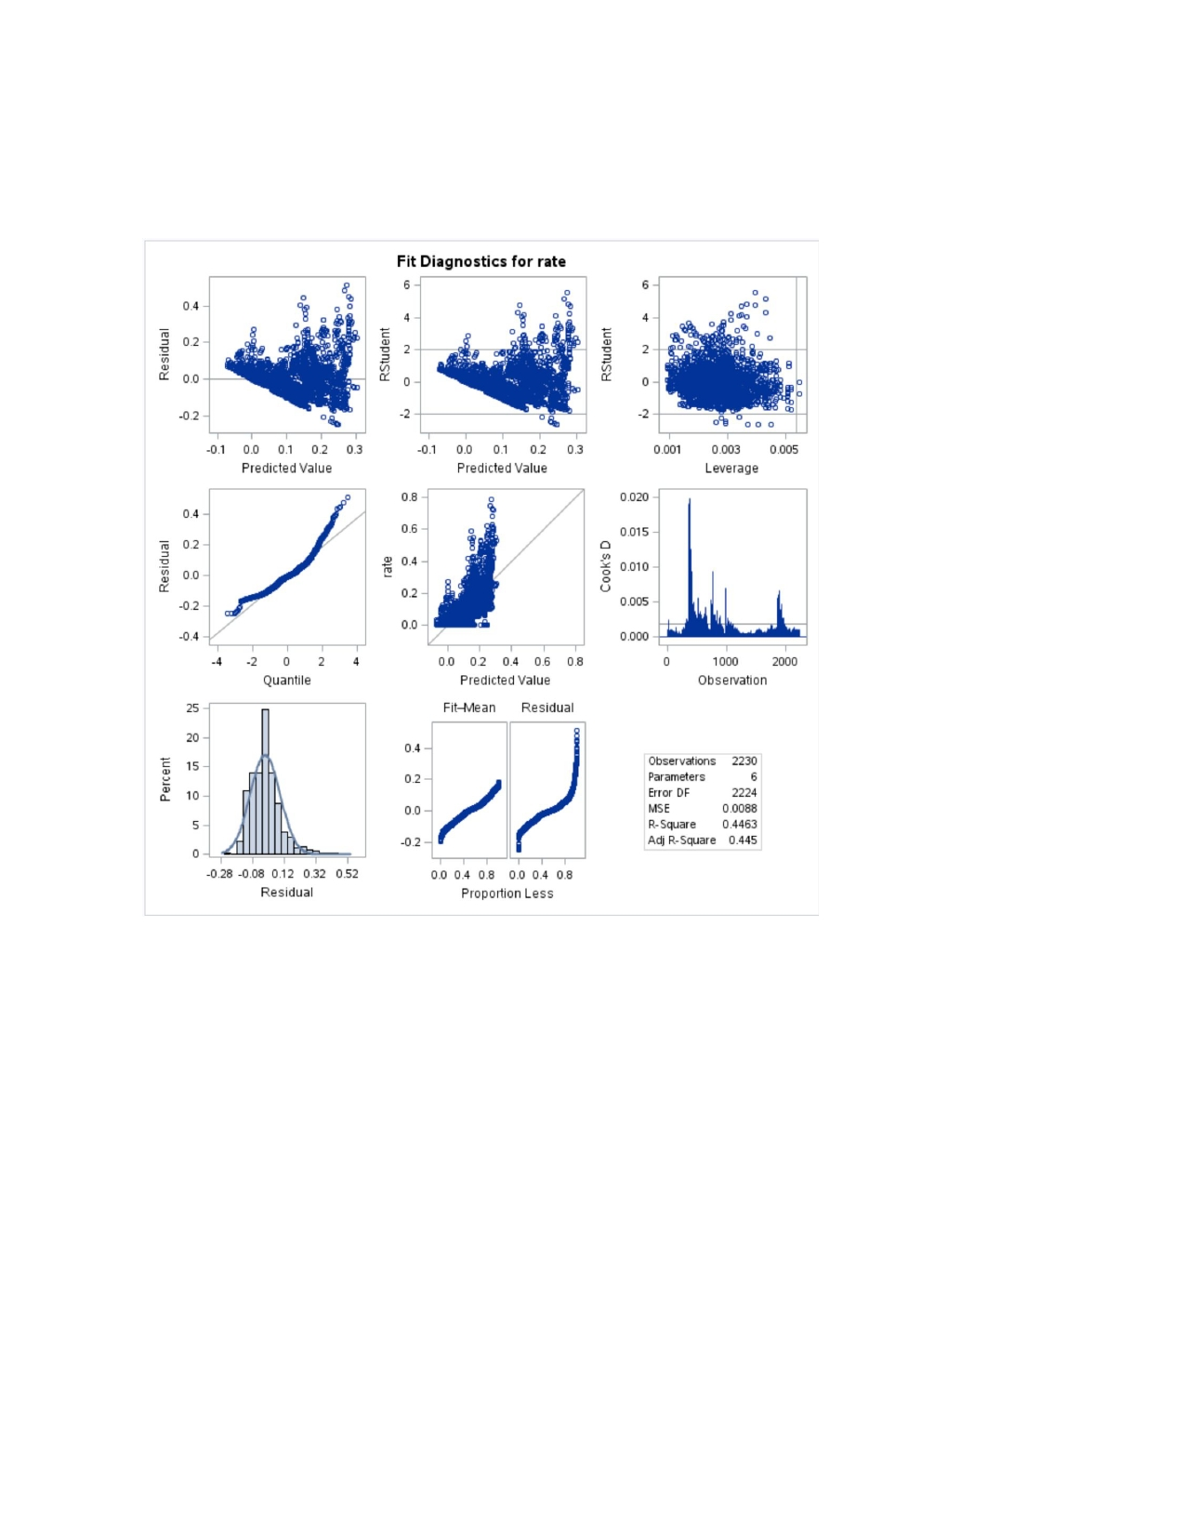

Panel 1. Graphical Diagnosis for the Fitting of Regression Model a.

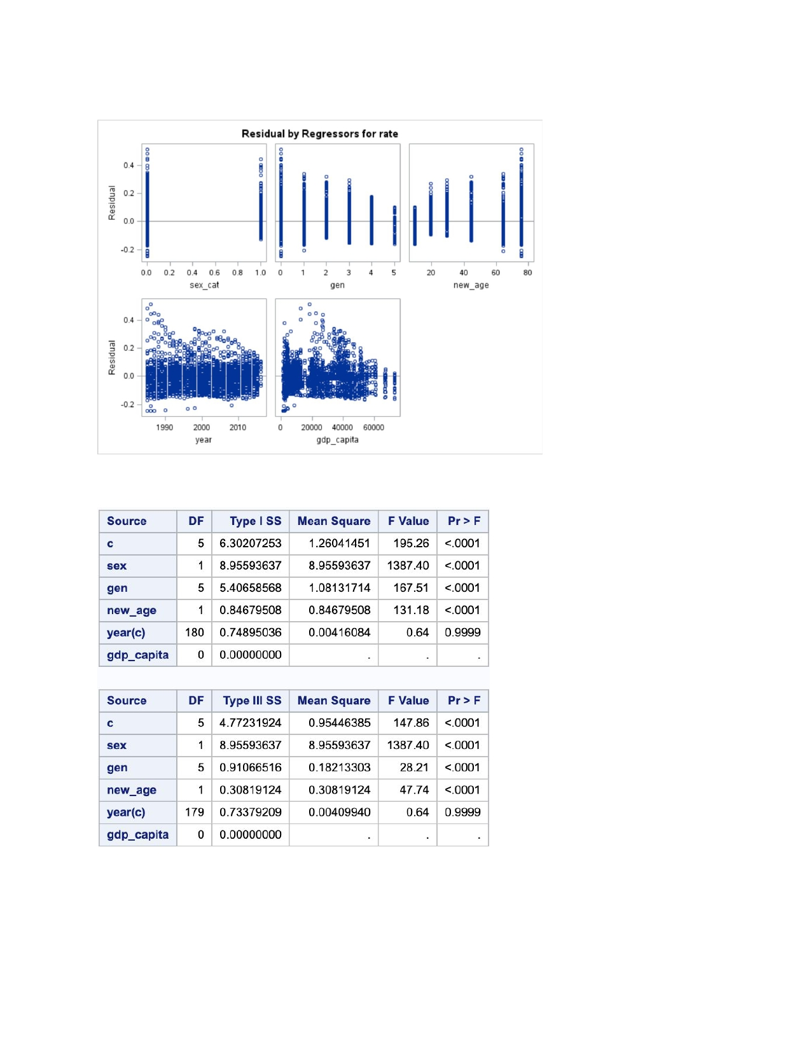

Panel 2. Residual Diagnostics for Regression Model a.

Table 1. Summary for Type I and Type III Analysis of Repeated-Measure ANOVA Model b.

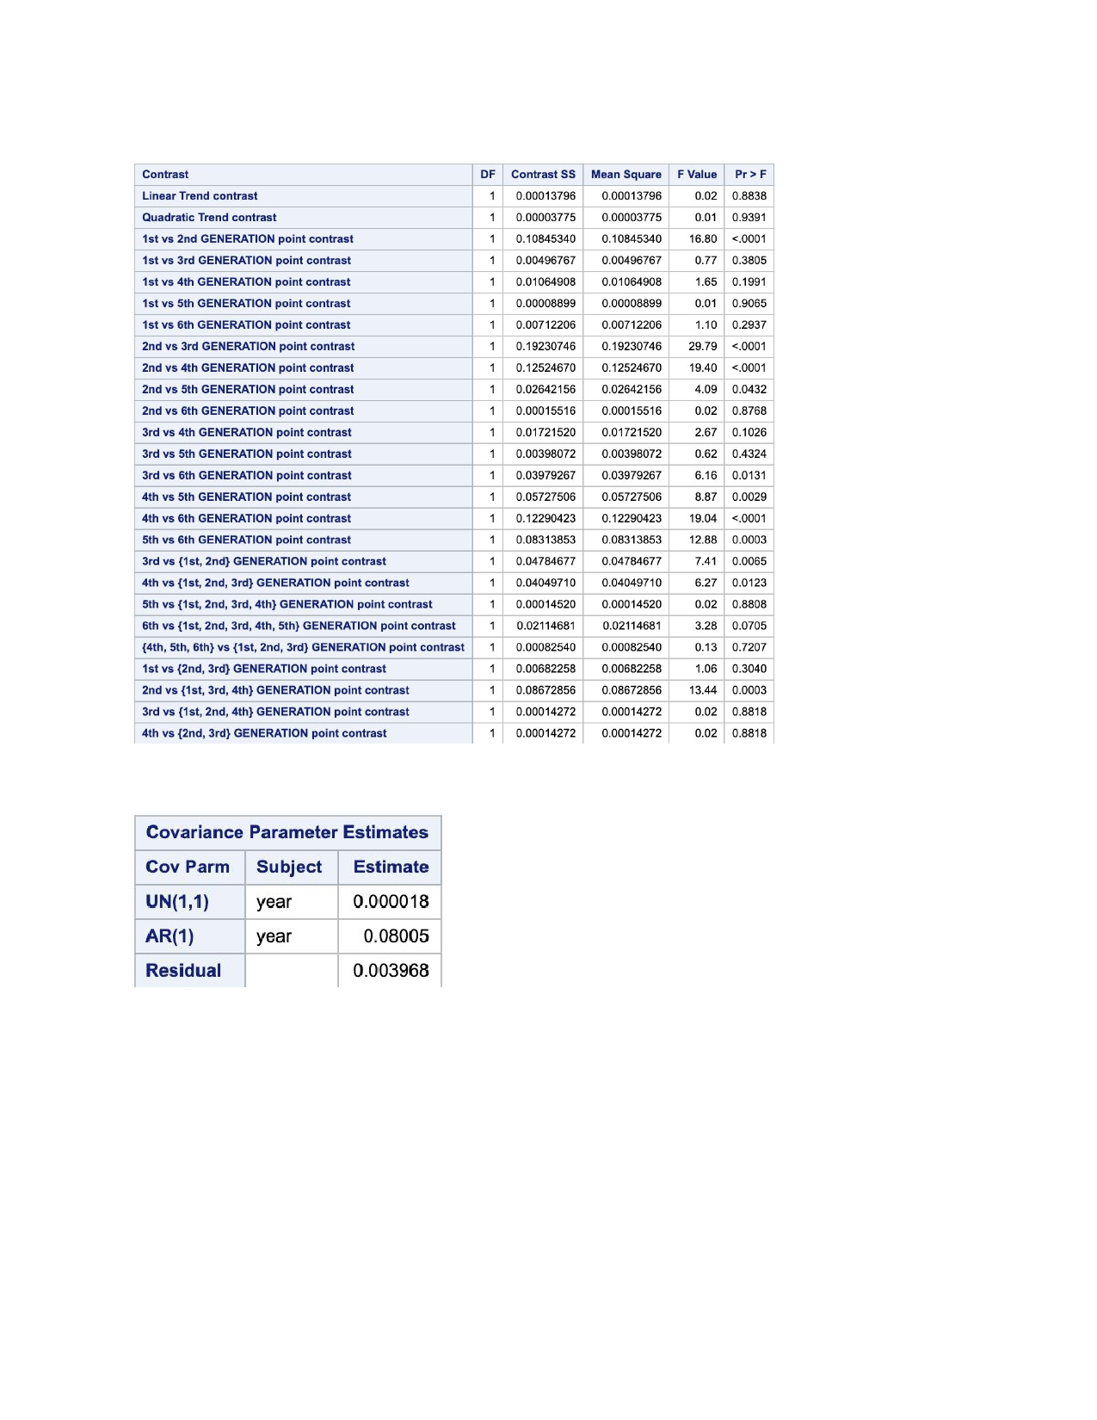

Table 2. Multiple Repeated-Measure Contrast Tests Summary

Table 3. Covariance Parameter Estimate for Linear Mixed Effect Model (d) Using AR(1)

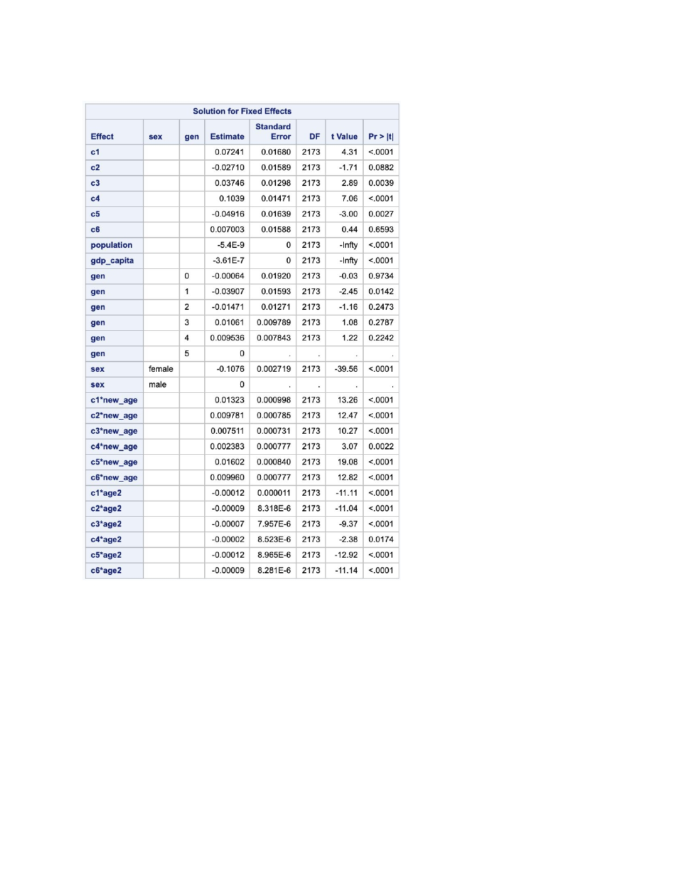

Table 4. Summary for Solutions for Fixed Effects from Linear Mixed-Effect Model d

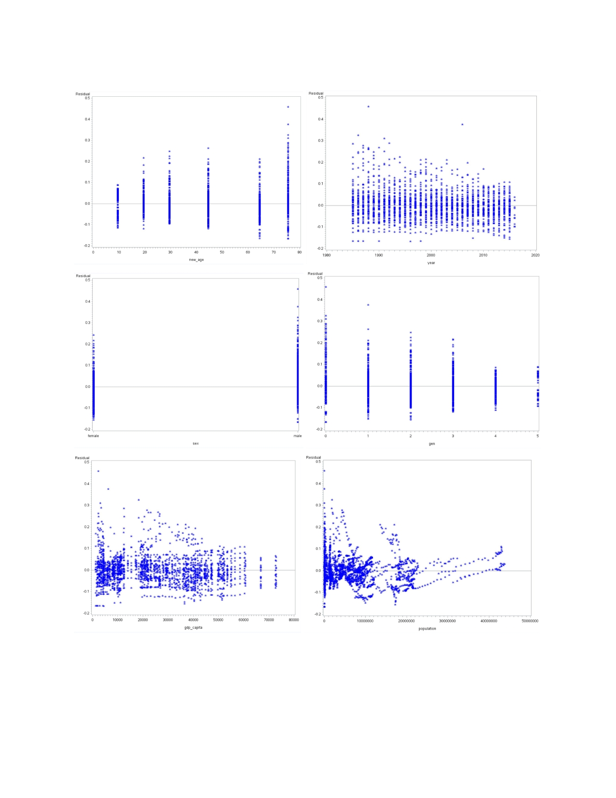

Panel 3. Population-averaged Raw Residuals Scatter Plots Against Covariates for Model d

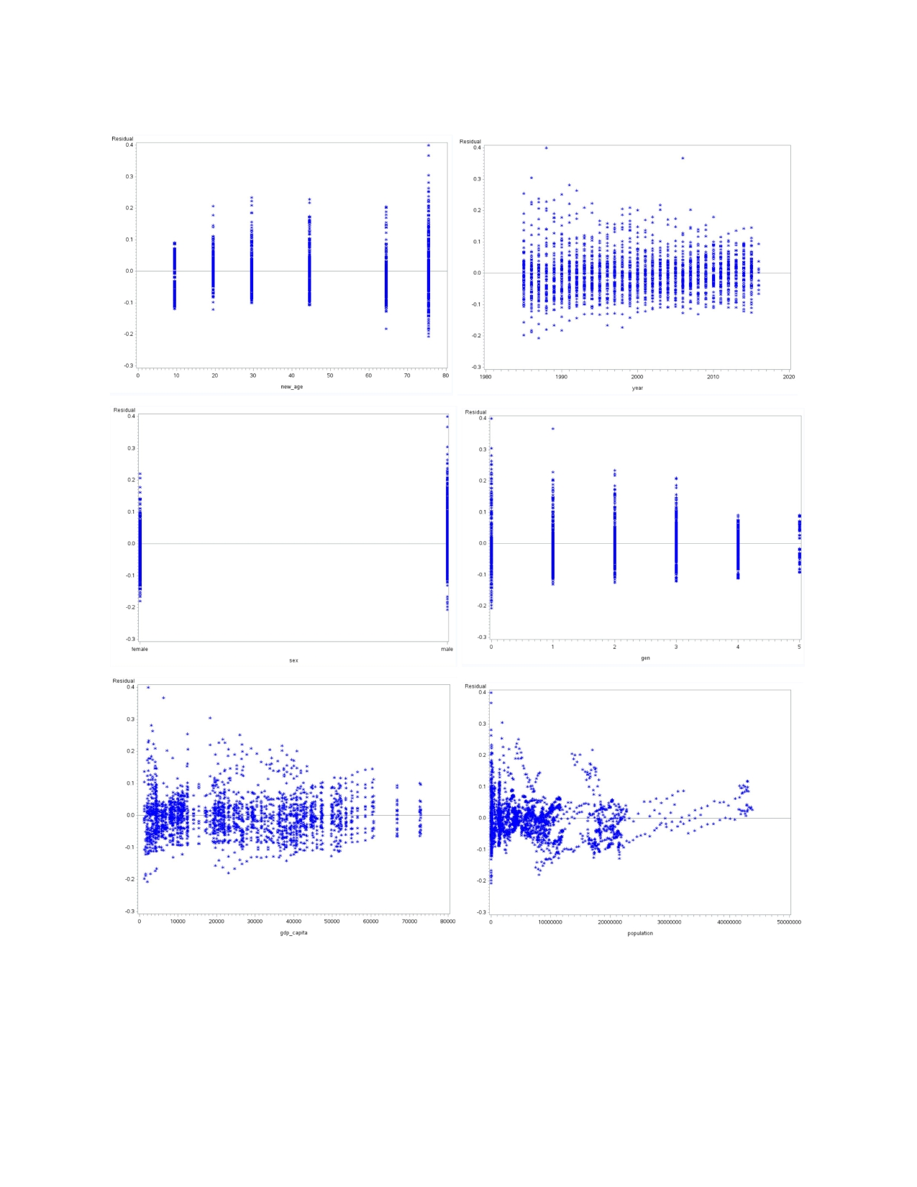

Panel 4. Subject-specific Raw Residuals Scatter Plots Against Covariates for Model d

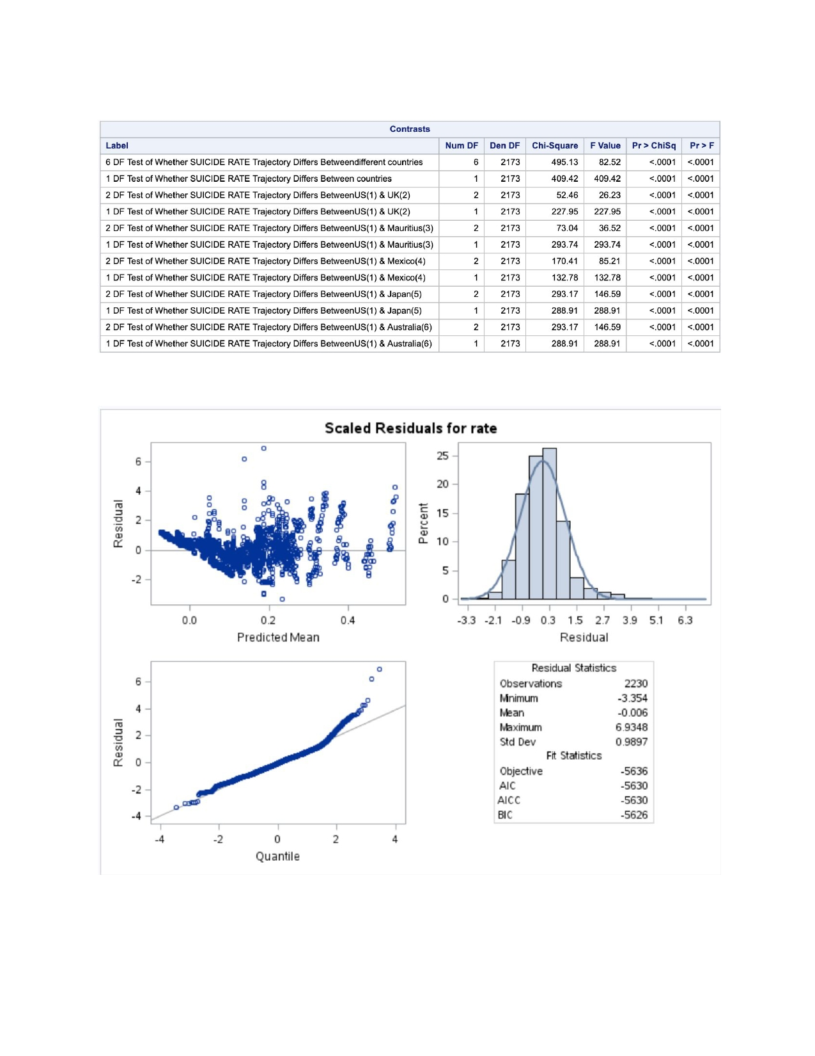

Table 5. Summary of Contrast Tests from Repeated-measure Fixed-effect Model (e)

Panel 5. Raw Residual Assumption Graphical Evaluations for Model e

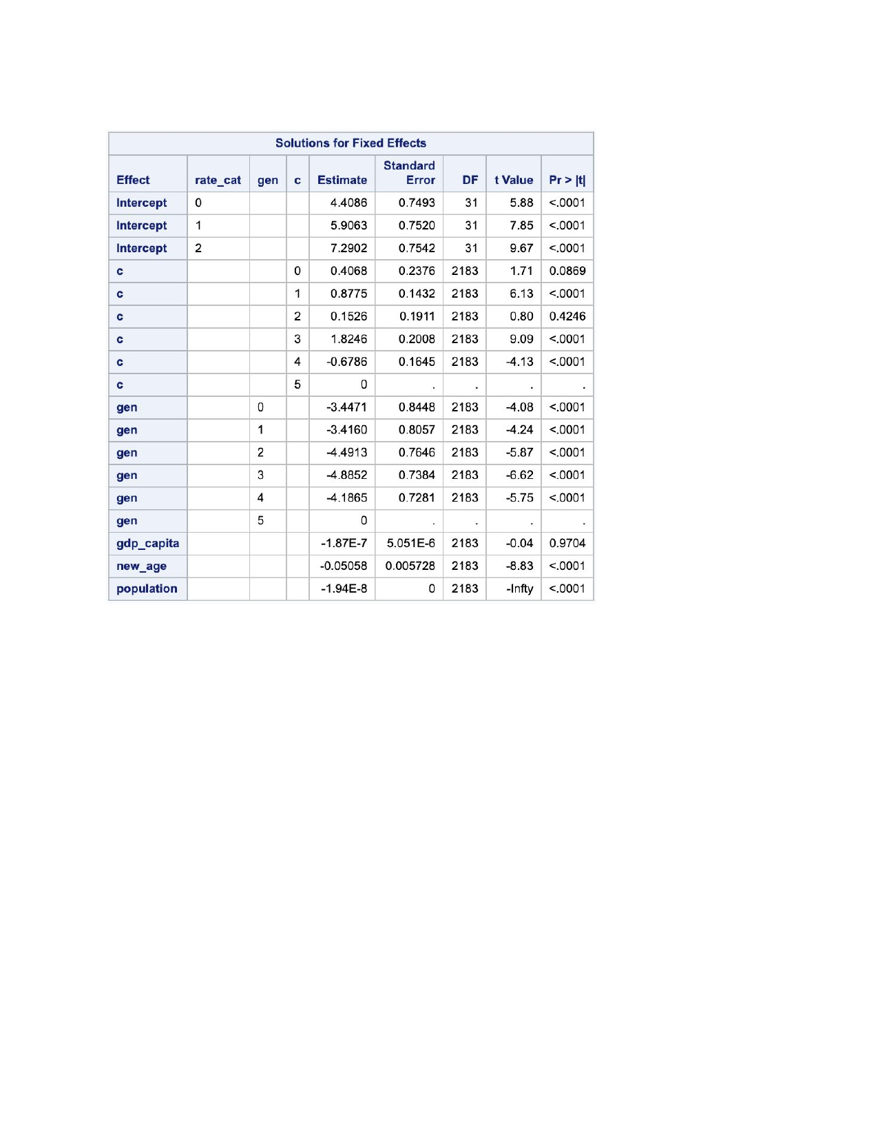

Table 6. Summary of Solutions for Fixed Effects from Model f